

SIMATS ENGINEERING

Saveetha Institute of Medical and Technical Sciences
Chennai- 602105

Student Name: Devadharshini E Reg. No:192524483
Course Code: UBA2892 Slot: D
Course Name: Professional ethics and legal practices for standards
Course Faculty: Dr. Shaafi T, Dr. Issac Dinaharan
Project Title: JIO PALATFORMS DATA MONETIZATION STRATEGY
Module Photographs: (3 photographs –Module Photo, Individual student contribution module work in the project and presentation image)
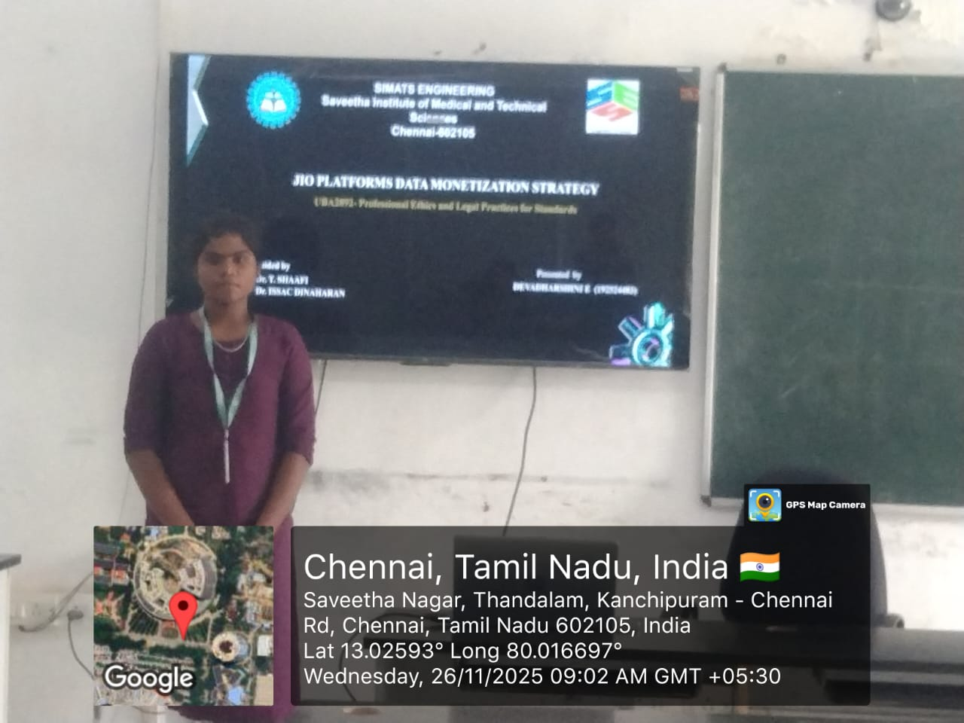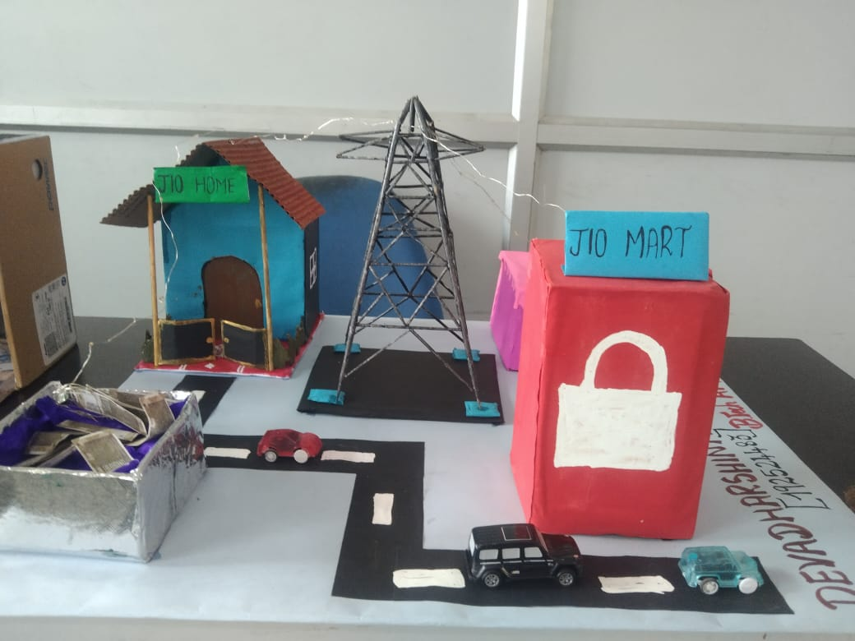
Project Description: (here you write what you did in this project (contribution) including Model Description
In this project, I analysed how Jio Platforms collects data from multiple digital services and converts it into revenue through data monetization. I studied different data sources such as Jio apps, 5G networks, IoT devices, cloud platforms, and e-commerce services. I also examined how these data streams flow into a central 5G hub and support Jio’s digital ecosystem. I designed the PPT by organising the content into clear sections like introduction, benefits of 5G, data flow model, monetization strategy, and Jio’s competitive advantages. I prepared a clear explanation for each slide and created a simple model where all data flows into the 5G tower and finally into the revenue box. Through this project, I understood how digital platforms use user behaviour, cloud computing, AI, and network data to create business value.

Student Signature Guide Signature

